Kanban

🧠 Definition
# Source: AI Source: Provided by: [Data Path: Persons Table -> ID Column: 1, Name_En Column: Motasem Essam] -> From: [ChatGPT] on [1/23/2026]
Kanban is a popular Agile framework used to visualize workflow, manage tasks, and improve efficiency. Unlike Scrum, it focuses on continuous delivery rather than fixed-length iterations (sprints).
Kanban is a visual workflow management method that helps teams optimize processes, reduce bottlenecks, and deliver work continuously.

🔁 How Kanban Works
# Source: AI Source: Provided by: [Data Path: Persons Table -> ID Column: 1, Name_En Column: Motasem Essam] -> From: [ChatGPT] on [1/23/2026]
- Work is represented as tasks (cards) on a board
- Tasks move through stages (e.g., To Do → In Progress → Done)
- Teams continuously pull new work when ready (no fixed sprints)
- Focus is on flow and efficiency rather than deadlines

📋 Kanban Board
# Source: AI Source: Provided by: [Data Path: Persons Table -> ID Column: 1, Name_En Column: Motasem Essam] -> From: [ChatGPT] on [1/23/2026]
A typical Kanban board has columns such as:
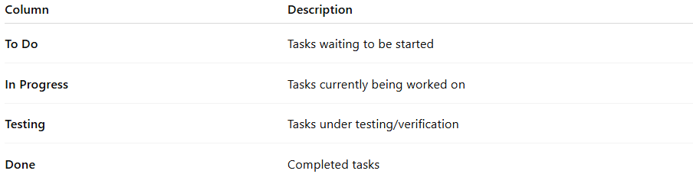
Column | Description
To Do | Tasks waiting to be started
In Progress | Tasks currently being worked on
Testing | Tasks under testing/verification
Done | Completed tasks

⚙️ Key Principles of Kanban
# Source: AI Source: Provided by: [Data Path: Persons Table -> ID Column: 1, Name_En Column: Motasem Essam] -> From: [ChatGPT] on [1/23/2026]
- Visualize work using boards and cards
- Limit Work in Progress (WIP) to avoid overload
- Manage flow to ensure smooth task movement
- Continuous improvement (Kaizen)
- Pull system (work is pulled, not pushed)

⚙️ Key Characteristics
# Source: AI Source: Provided by: [Data Path: Persons Table -> ID Column: 1, Name_En Column: Motasem Essam] -> From: [ChatGPT] on [1/23/2026]
- No fixed roles (unlike Scrum)
- No time-boxed iterations
- Continuous delivery of work
- Focus on workflow optimization
- Flexible and easy to implement

✅ Advantages
# Source: AI Source: Provided by: [Data Path: Persons Table -> ID Column: 1, Name_En Column: Motasem Essam] -> From: [ChatGPT] on [1/23/2026]
- Simple and easy to understand
- Highly flexible (no strict rules or roles)
- Improves workflow visibility
- Reduces bottlenecks and delays
- Continuous delivery without waiting for sprint completion

⚠️ Disadvantages
# Source: AI Source: Provided by: [Data Path: Persons Table -> ID Column: 1, Name_En Column: Motasem Essam] -> From: [ChatGPT] on [1/23/2026]
- Lack of structure compared to Scrum
- Harder to predict timelines
- Requires discipline to manage WIP limits
- Less focus on team roles and responsibilities

📝 When to Use Kanban
# Source: AI Source: Provided by: [Data Path: Persons Table -> ID Column: 1, Name_En Column: Motasem Essam] -> From: [ChatGPT] on [1/23/2026]
- Projects requiring continuous delivery
- Support and maintenance tasks
- Teams needing flexibility and workflow visibility
- Environments with frequent incoming tasks

📌 Summary
# Source: AI Source: Provided by: [Data Path: Persons Table -> ID Column: 1, Name_En Column: Motasem Essam] -> From: [ChatGPT] on [1/23/2026]
Kanban is an Agile framework focused on visualizing work, limiting work in progress, and improving workflow efficiency. Unlike Scrum, it does not use sprints and supports continuous delivery, making it ideal for dynamic environments and ongoing tasks.

